**Lab Exercise 6- Reading an LDR with Arduino and Printing the Value on Serial Monitor**

In this lab exercise, you will learn how to read values from an LDR using an Arduino and print the readings to the Serial Monitor. The LDR changes its resistance based on the amount of light it receives, allowing you to measure light intensity.

**Objective:**

* Read the resistance of an LDR and display the corresponding analog value on the Serial Monitor.

**Materials Needed:**

* Arduino board (e.g., Arduino Uno)
* 1x Light Dependent Resistor (LDR)
* 1x 10kΩ resistor (for a voltage divider)
* Breadboard
* Jumper wires
* USB cable to connect the Arduino to your computer

**Circuit Diagram:**

1. Connect the components as follows:
   * Connect one end of the **LDR** to **5V** on the Arduino.
   * Connect the other end of the **LDR** to one end of the **10kΩ resistor**.
   * Connect the other end of the **10kΩ resistor** to **GND**.
   * Connect the junction between the **LDR** and the **10kΩ resistor** to **Analog Pin A0**.

Here’s a simple circuit diagram:

Simulation Diagram:

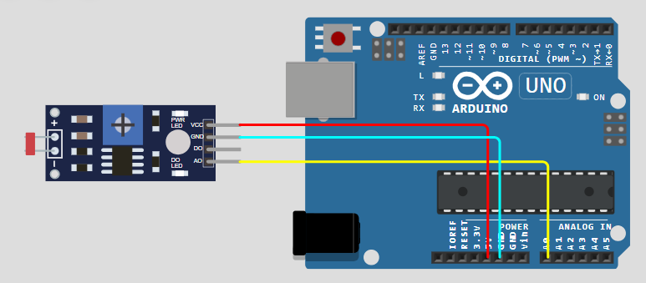

**Steps to Perform the Lab:**

**Step 1: Set Up the Arduino IDE**

1. Open the Arduino IDE.
2. Connect your Arduino board to your computer via the USB cable.
3. In the **Tools** menu, select the correct **Board** (e.g., Arduino Uno) and **Port**.

**Step 2: Write the Arduino Code**

1. **Code to Read the LDR Value:**

// Define the pin for the LDR

const int ldrPin = A0; // LDR connected to Analog Pin A0

void setup() {

// Initialize Serial communication at 9600 baud

Serial.begin(9600);

}

void loop() {

// Read the value from the LDR

int ldrValue = analogRead(ldrPin);

// Print the value to the Serial Monitor

Serial.print("LDR Value: ");

Serial.println(ldrValue);

// Wait for a second before the next reading

delay(1000);

}

1. **Explanation:**
   * The LDR is connected to **Analog Pin A0**. The code reads the analog value from this pin.
   * In setup(), we start serial communication at a baud rate of 9600.
   * In loop(), we read the value from the LDR using analogRead(ldrPin), print it to the Serial Monitor, and wait for 1 second before the next reading.

**Step 3: Upload the Code**

1. Upload the code to the Arduino by clicking the **Upload** button (right arrow icon).
2. Open the **Serial Monitor** in the Arduino IDE (Tools > Serial Monitor or press **Ctrl+Shift+M**).

**Step 4: Test the LDR Reading**

1. Once the Serial Monitor is open, you should see readings of the LDR value being printed every second.
2. You can test the LDR by covering it with your hand or a piece of paper to see how the readings change in different lighting conditions.

**Step 5: Experimentation**

* **Modify the Code:**
  + Change the delay time to see how the readings vary with faster or slower intervals.
  + Add conditions to print different messages based on the LDR value. For example:

if (ldrValue < 400) {

Serial.println("It’s dark!");

} else {

Serial.println("It’s bright!");

}

**Additional Features:**

* + Implement a feature to log the readings to an SD card if you have an SD card module available.

**Summary of Key Concepts:**

* **Analog Input:** Reading an analog value from the LDR using analogRead().
* **Serial Communication:** Sending the LDR values to the Serial Monitor for real-time feedback.
* **Voltage Divider:** Using a voltage divider circuit to convert light intensity into a readable voltage.